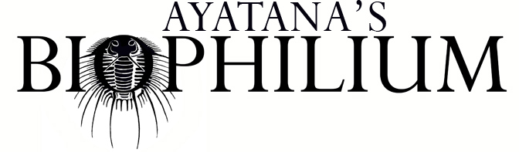

Which residency are you applying for?
If you are interested in more than one program, please indicate your preference.
Online 2026:
☐ Locomotion: Autonomy and navigation in biology
☐ Metamorph: Transformation in biology and ecology
☐ Rewild: Habitat Conservation and ecological restoration
☐ Sweet Nothing: Sex in the wild
☐ Mycophilia: Mushrooms and fungi for artists
☐ Germinate: Botany for artists
☐ Bird Nerds: Ornithology for artists
☐ Ritual: Science for witches
☐ Mortem: Death school for artists
In Person:
☐ Mycophilia: Mushroom Hunting Ontario Forests
☐ Would you attend more than one of the programs you chose?

There is no application process for Brain Club. You can register directly on the web page or send us a hello and ask for the Zoom link and info. Artlovesscience@gmail.com

Name:

City of residence:

Email address:

Website and/or social media:

If you participate, can we post your artist statement and an image on our website?

Is there something specific you are studying (a species or concept for example) that we can include in the program to make the residency more useful for your practice?
Where did you hear about this call for applications?

